Lab 1
2.
cat | more
Reads the full content of the file | Reads the content of the file one screen at a time
3.
rm | rmdir
Removes file/can remove directory with contained files | Removes directory (have to be empty)
4. Create the following hierarchy under your home directory:
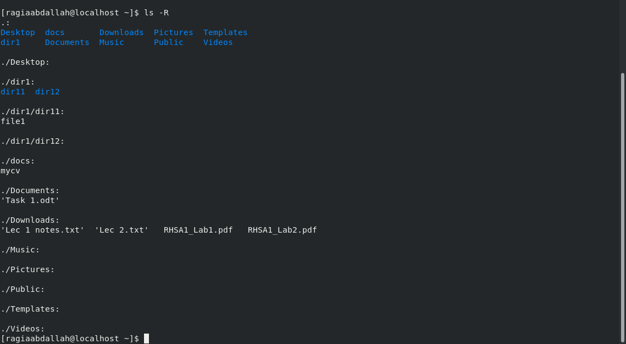
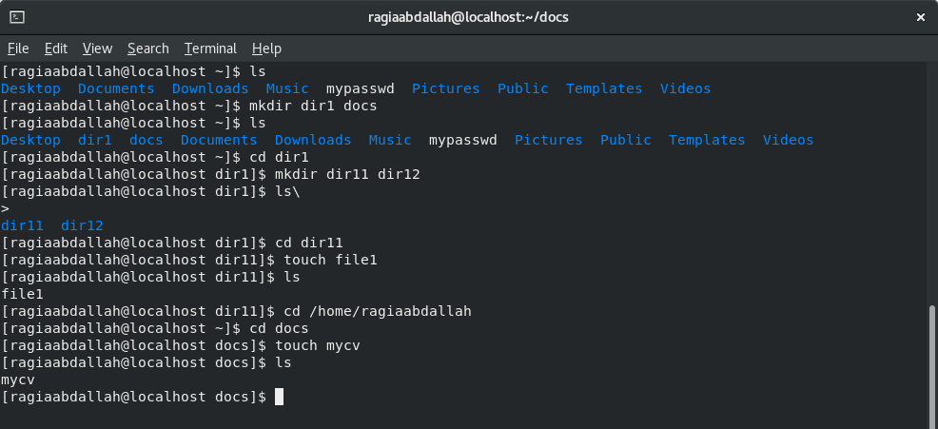
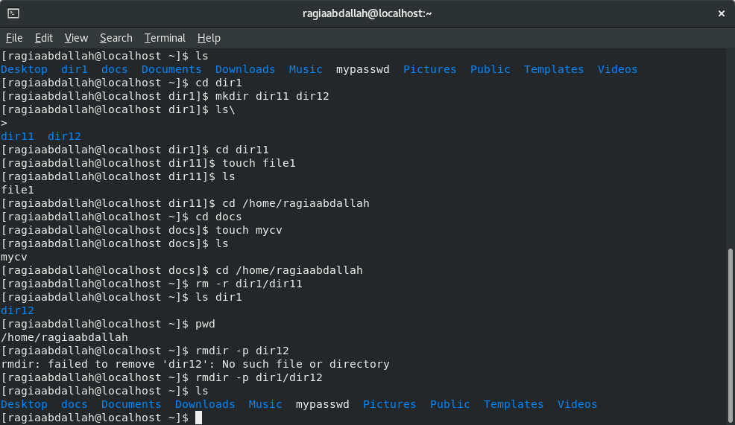
4.a. rmdir won’t work on the directory as it’s not empty

solution: use rm -r to delete the directory with its content

4.b.
option -p deleted the parent of the directory given

4.c. path: /home/ragiaabdallah/docs/mycv
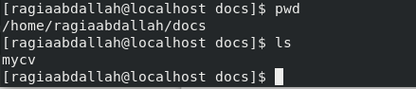

5. Copy the /etc/passwd file to your home directory making its name is mypasswd:
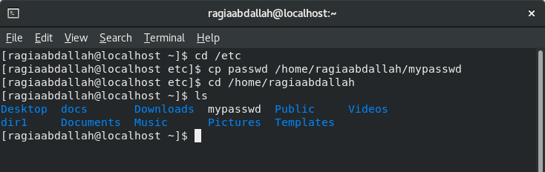

6. Rename this new file to be oldpasswd:
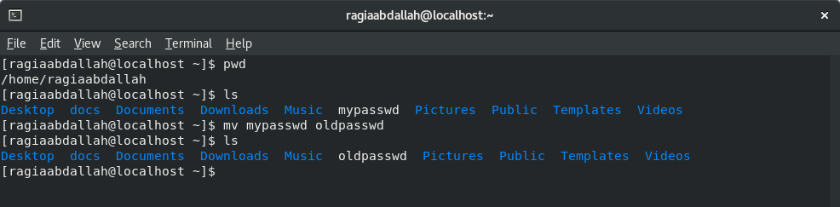
7. You are in /usr/bin, list four ways to go to your home directory:
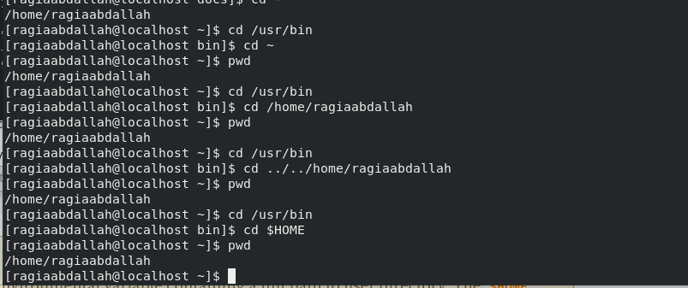
8. List Linux commands in /usr/bin that start with letter w:
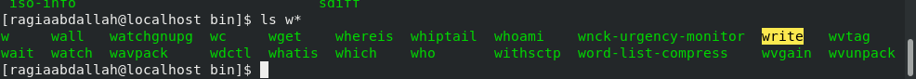
9. Display the first 4 lines of /etc/passwd:
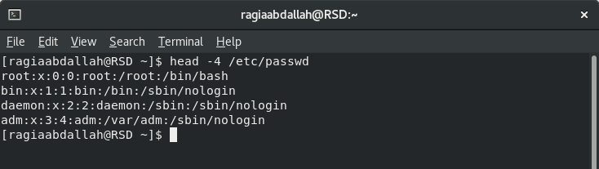

10. Display the last 7 lines of /etc/passwd:
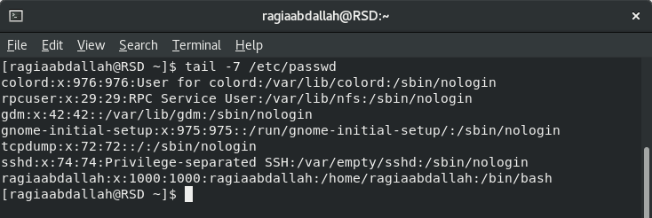
11. Display the man pages of passwd the command and the file sequentially in one command:
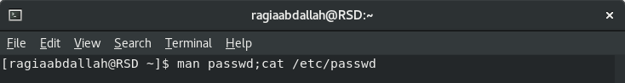
12. Display the man page of the passwd file:
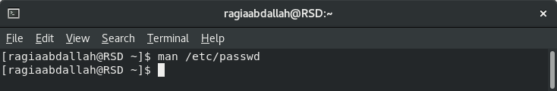
13. Display a list of all the commands that contain the keyword passwd in their man page:
